# Q1. Write a program to perform the following operations on an array A[10]: insert an element in between, delete an element in between, print the array, reverse the array (into new array).

#include <stdio.h>

#include <stdlib.h>

int main()

{

char ch;

int arr[12]={0,1,2,3,4,5,6,7,8,9};

//Asking user for the operation to be performed.

printf("Do you want to insert(i), delete(d), print(p) or reverse print(r)=");

scanf("%c",&ch);

//Condition for insertion.

if(ch=='i')

{

int j, y, place;

//Asking user for the input for insertion.

printf("Element to be inserted=");

scanf("%d",&y);

//Asking user for the positon where insertion need to happen.

printf("Position=");

scanf("%d",&place);

//Loop for shifting the element forward.

for (j = 10; j>=place; j--)

{

arr[j] = arr[j - 1];

}

//Inserting the user element to its desired position.

arr[place-1]=y;

//For priniting the modified array.

for (j = 0; j<11; j++)

{

printf("%d ", arr[j]);

printf("\n");

}

}

//Condition for deletion.

else if(ch=='d')

{

int place;

//Asking user for the position of the deletion to happen.

printf("Position=");

scanf("%d",&place);

//Loop for backward shifting of elements.

for(int j=place-1; j<=9; j++)

{

arr[j]=arr[j+1];

}

//Loop for printing the modified array.

for (int j = 0; j<9; j++)

{

printf("%d\n", arr[j]);

}

}

//Loop for printing the array.

else if(ch=='p')

{

for (int j = 0; j<9; j++)

{

printf("%d\n", arr[j]);

}

}

//Loop for reverse printing the array.

else if(ch=='r')

{

int A[12];

for (int j = 0; j<10; j++)

{

//Reverse entry to new array.

A[9-j]=arr[j];

}

//For printing the new array with reverse entries.

for (int j=0; j<10; j++)

{

printf("%d\n",A[j]);

}

}

return 3;

}

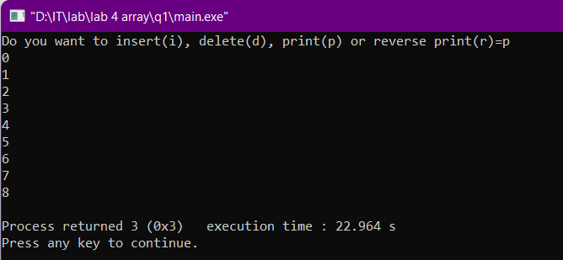

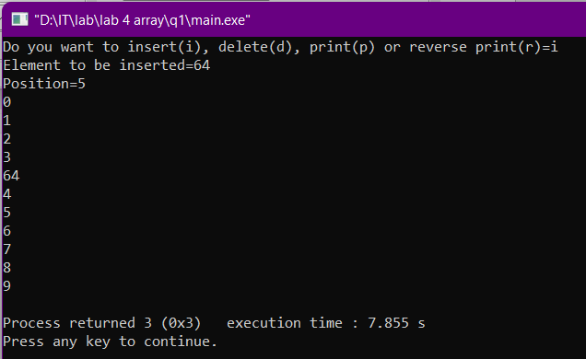

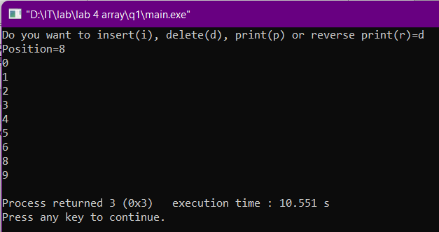

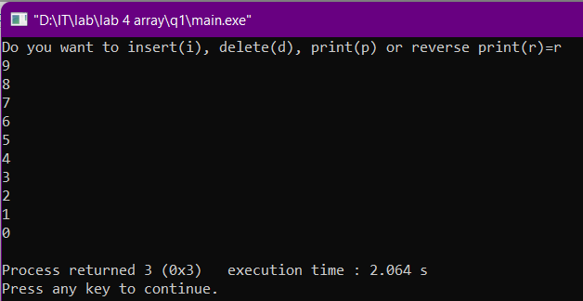

# Q2. Write a program to take an array A[10] with values from

# user input and find the following: largest element, smallest

# element, mean value, even valued elements,and odd valued elements

#include <stdio.h>

#include <stdlib.h>

int main()

{

int A[10];

printf("Enter the values inside the array A[10]\n");

//ARRAY FORMATION

for(int i=0;i<10;++i)

{

scanf("%d",&A[i]);

}

//CALCULATION OF MIN,MAX,ODD & EVEN

int max=A[0];

int min=A[0];

int sum=0;

int odd,even;

for(int i=0;i<10;++i)

{

if(A[i]>max) max=A[i];

if(A[i]<min) min=A[i];

sum=sum+A[i];

}

printf("The largest element in the given array is : %d\n",max);

printf("The smallest element in the given array is : %d\n",min);

printf("The mean of the given array is : %.1f\n",(sum/10.0));

printf("The even elements in the given array are : ");

for(int i=0;i<10;++i)

{

if(A[i]%2==0) printf("%d ",A[i]);

}

printf("\nThe odd elements in the given array are : ");

for(int i=0;i<10;++i)

{

if(A[i]%2!=0) printf("%d ",A[i]);

}

return 3;

}

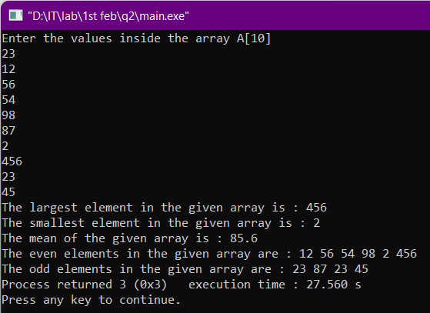

# Q3. Write a program to perform the following: addition of the two 2*3 matrices, multiplication of two compatible matrices, transpose of a 3*4 matrix, and determinant of a 3*3 matrix.

#include <stdio.h>

#include <stdlib.h>

int main()

{

//forming matrix A

int A[2][3];

printf("Enter the value inside 2*3 matrix A -->\n");

for(int i=0;i<2;++i)

{

for(int j=0;j<3;++j)

{

scanf("%d",&A[i][j]);

}

}

//FORMING MATRIX B

int B[2][3];

printf("\nEnter the value inside 2*3 matrix B -->\n");

for(int i=0;i<2;++i)

{

for(int j=0;j<3;++j)

{

scanf("%d",&B[i][j]);

}

}

//PERORMING ADDITION OPERATION

int C[2][3];

printf("\nThe sum of the matrix A & B is -->\n");

for(int i=0;i<2;++i)

{

for(int j=0;j<3;++j)

{

C[i][j] = A[i][j] + B[i][j];

printf("%d ",C[i][j]);

}

printf("\n");

}

//PERFORMING MULTIPLICATION OPERATION

int a,b,c;

printf("\nEnter no of rows and columns in 1st matrix : ");

scanf("%d %d",&a,&b);

printf("Enter no of columns in 2nd matrix : ");

scanf("%d",&c);

int m[a][b], n[b][c], p[a][c];

int sum=0,temp;

printf("Enter elements of 1st matrix\n");

for(int i=0;i<a;++i){

for(int j=0;j<b;++j){

// if(j==(b-1))

scanf("%d",&m[i][j]);

}

}

printf("Enter elements of 2nd matrix\n");

for(int i=0;i<b;++i){

for(int j=0;j<c;++j){

scanf("%d",&n[i][j]);

}

}

printf("The product of the matrix is\n");

for(int i=0;i<a;++i){

for(int j=0;j<c;++j){

for(int k=0;k<b;++k){

temp=m[i][k]*n[k][j];

sum=sum+temp;

}

p[i][j]=sum;

printf("%d ",p[i][j]);

sum=0;

}

printf("\n");

}

//PERFORMING TRANSPOSE OPERATION

printf("Enter elements of 3*4 matrix\n");

int o[3][4];

for(int i=0;i<3;++i){

for(int j=0;j<4;++j){

scanf("%d",&o[i][j]);

}

}

printf("Transpose of the above matrix is \n");

int t[4][3];

for(int i=0;i<3;++i){

for(int j=0;j<4;++j){

t[j][i]=o[i][j];

}

}

for(int i=0;i<4;++i){

for(int j=0;j<3;++j){

printf("%d ",t[i][j]);

}

printf("\n");

}

//PERFORMING DETERMINANT OPERATION

int d[3][3];

printf("\nEnter the value inside 3*3 matrix d\n");

for(int i=0;i<3;++i){

for(int j=0;j<3;++j){

scanf("%d",&d[i][j]);

}

}

int det=0;

det=det+d[0][0]*((d[1][1]*d[2][2])-(d[2][1]*d[1][2]))-d[1][0]*(d[1][0]*d[2][2]-d[2][0]*d[1][2])+d[0][2]*(d[1][0]*d[2][1]-d[2][0]*d[1][1]);

printf("Determinant of the 3*3 matrix is : %d",det);

return 3;

}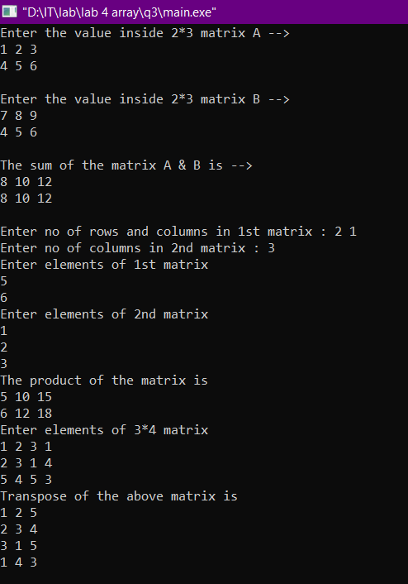

# Q4. Write a program to search and print the FIRST occurrence of an element in an array. Print"not found" if absent. Take 10 numbers as the array elements input and an 11th number as the search element.

#include <stdio.h>

#include <stdlib.h>

int main()

{

int arr[10];

printf("Enter the values inside the array arr[10]\n");

for(int i=0;i<10;++i)

{

scanf("%d",&arr[i]);

}

int a;

printf("\nEnter the search element : ");

scanf("%d",&a);

//SEARCHING PROCESS BEGINS

int count=0;

for(int i=0;i<10;++i)

{

if(a==arr[i])

{

printf("\nThe first occurence of the element %d is at index %d",a,i);

count+=1;

break;

}

}

if(count==0) printf("\nnot found");

return 3;

}

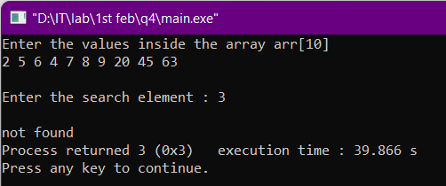

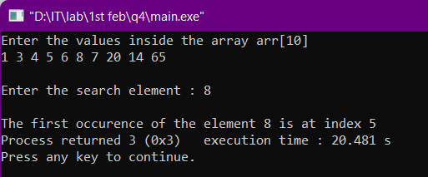

# Q5. Write a program to print the most frequent element in a 15-number array. If all are unique, print accordingly.

#include <stdio.h>

#include <stdlib.h>

int main()

{

int i,j,k;

int a[15]={0,1,2,3,1,4,6,7,2,9,1,1,2,3,4};

for(i=0;i<15;++i){

printf("%d ",a[i]);

}

printf(“\n”);

for(i=0;i<15;++i){

int host=0,end=0;

for(k=0;k<i;++k){

if(a[k]==a[i]){

end=1;

break;

}

}

if(end==0){

for(j=0;j<15;++j){

if(a[j]==a[i])

++host;

}

printf("Occurence of %d is %d times\n",a[i],host);

}

}

return 0;

}

